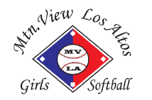
Expense Reimbursement Request
Fill out form, attach receipt and send request to MVLAGS, P.O. BOX 4264, Mountain View, CA 94040 or treasurer@mvlags.org

Name |  | Check | PayPal
Address
PayPal Address

Type | Description | League Code | Amount
 |  | Total:

Signature Date submitted
NOTE: Please attach receipts.
Type Examples  Fields  Equipment  Publicity  Office Supplies  Snack Shack  Copying (non-publicity)  Safety  Uniforms  Umpire Program | League Codes  R = Recreation League  NF – Nova Fall  NS = Nova Summer  SS = Summer Stars

